# VISVESVARAYA TECHNOLOGICAL UNIVERSITY

## BELAGAVI – 590018, Karnataka INTERNSHIP REPORT

#### ON

“Travel Blogging Site”

***Submitted in partial fulfillment for the award of degree(18CSI85)***

## BACHELOR OF ENGINEERING IN

## INFORMATION SCIENCE

***Submitted by:***

#### Rohith Hande

#### 1JB21IS401



Conducted at

**VARCONS TECHNOLOGIES**



# SJBIT INSTITUTE OF TECHNOLOGY

**Department of ISE**

**Accredited by NBA, New Delhi**

# KENGERI

# SJBIT INSTITUTE OF TECHNOLOGY

**Department of ISE**

**Accredited by NBA, New Delhi**

# KENGERI,BANGALORE



**CERTIFICATE**

This is to certify that the Internship titled **“TRAVEL BLOG SITE”** carried out by **Mr. H ROHITH HANDE,** a bonafide student of SJBIT Institute of Technology, in partial fulfillment for the award of **Bachelor of Engineering**, in **ISE** under Visvesvaraya Technological University, Belagavi, during the year 2022-2023. It is certified that all corrections/suggestions indicated have been incorporated in the report.

The project report has been approved as it satisfies the academic requirements in respect of Internship prescribed for the course Internship / Professional Practice (18CSI85)

#### Signature of Guide Signature of HOD Signature of Principal

**External Viva:**

Name of the Examiner Signature with Date

1)

2)

# D E C L A R A T I O N

I, ROHITH HANDE, final year student of ISE, SJBIT - 560 082, declare that the Internship has been successfully completed, in VARCONS TECHNOLOGIES. This report is submitted in partial fulfillment of the requirements for award of Bachelor Degree in Branch name, during the academic year 2022-2023.

Date :20-09-2023 :

Place : HALSURU

USN : 1JB21IS401

NAME : H ROHITH HANDE

**OFFER LETTER PROVIDED BY THE COMPANY**

# A C K N O W L E D G E M E N T

This Internship is a result of accumulated guidance, direction and support of several important persons. We take this opportunity to express our gratitude to all who have helped us to complete the Internship.

We express our sincere thanks to our Principal, for providing us adequate facilities to undertake this Internship.

We would like to thank our Head of Dept – branch code, for providing us an opportunity to carry out Internship and for his valuable guidance and support.

We would like to thank our (Lab assistant name) Software Services for guiding us during the period of internship.

We express our deep and profound gratitude to our guide, Guide name, Assistant/Associate Prof, for her keen interest and encouragement at every step in completing the Internship.

We would like to thank all the faculty members of our department for the support extended during the course of Internship.

We would like to thank the non-teaching members of our dept, forhelping us during the Internship.

Last but not the least, we would like to thank our parents and friends without whose constant help, the completion of Internship would have not been possible.

**NAME**

**USN**

# ABSTRACT

This study used published travel blog narratives to investigate MTEs. Two major findings were revealed by the study: (1) MTEs are mostly reported as positive experiences rather than negative ones and (2) seven experiential themes are closely linked with MTEs. The finding of insignificant number of negative experiences in the blogs is consistent with the claim that individuals tend to retain memories of highly positive rather than negative events. Walker, Skowronski, and Thompson (2003) suggest two likely reasons for people to be more biased towards recollecting positive events: firstly, people generally perceive events in their lives as more pleasant than unpleasant and; secondly, memories associated with unpleasant events fade faster than memories of pleasant events. The finding implies that enhancing the likelihood that visitors encounter more pleasant and positive experiences during their travels will help destinations to imprint more positive memories in travellers’ minds. The content analysis of the narratives revealed seven experiential dimensions of MTEs.

# Table of Contents

|  |  |  |
| --- | --- | --- |
| **Sl no** | **Description** | **Page no** |
| 1 | Company Profile |  |
| 2 | About the Company |  |
| [3](https://1.bp.blogspot.com/-dODuK8N5h1Q/Wlnyb3V9HFI/AAAAAAAACL4/WxQtCJ1pM5wccDABg4wIrTBUB0vlikXQQCLcBGAs/s1600/poly1.jpg) | Introduction |  |
| [4](https://1.bp.blogspot.com/-dODuK8N5h1Q/Wlnyb3V9HFI/AAAAAAAACL4/WxQtCJ1pM5wccDABg4wIrTBUB0vlikXQQCLcBGAs/s1600/poly1.jpg) | System Analysis |  |
| [5](https://1.bp.blogspot.com/-dODuK8N5h1Q/Wlnyb3V9HFI/AAAAAAAACL4/WxQtCJ1pM5wccDABg4wIrTBUB0vlikXQQCLcBGAs/s1600/poly1.jpg) | Requirement Analysis |  |
| 6 | Design [Analysis](https://4.bp.blogspot.com/-IOOxgPaXMVc/Wlj3LWvcnjI/AAAAAAAACKE/UeTFYvAxDmUDel5UBjdifeWaApB3-dXVgCLcBGAs/s1600/img1.jpg) |  |
| 7 | [Feedback](https://4.bp.blogspot.com/-IOOxgPaXMVc/Wlj3LWvcnjI/AAAAAAAACKE/UeTFYvAxDmUDel5UBjdifeWaApB3-dXVgCLcBGAs/s1600/img1.jpg) |  |
| 8 | Snapshots |  |
| 9 | Conclusion |  |
| 10 | References |  |

**[CHAPTER](https://1.bp.blogspot.com/-dODuK8N5h1Q/Wlnyb3V9HFI/AAAAAAAACL4/WxQtCJ1pM5wccDABg4wIrTBUB0vlikXQQCLcBGAs/s1600/poly1.jpg) 1** **COMPANY PROFILE**

# COMPANY PROFILE

## A Brief History of Company Name

Varcons Technologies, was incorporated with a goal ”To provide high quality and optimal Technological Solutions to business requirements of our clients”. Every business is a different and has a unique business model and so are the technological requirements. They understand this and hence the solutions provided to these requirements are different as well. They focus on clients requirements and provide them with tailor made technological solutions. They also understand that Reach of their Product to its targeted market or the automation of the existing process into e-client and simple process are the key features that our clients desire from Technological Solution they are looking for and these are the features that we focus on while designing the solutions for their clients.

Varcons technologies is a Technology Organization providing solutions for all web design and development, MYSQL, PYTHON Programming, HTML, CSS, ASP.NET and LINQ. Meeting the ever increasing automation requirements, Sarvamoola Software Services. specialize in ERP, Connectivity, SEO Services, Conference Management, effective web promotion and tailor-made software products, designing solutions best suiting clients requirements.

Varcons technologie, strive to be the front runner in creativity and innovation in software development through their well-researched expertise and establish it as an out of the box software development company in Bangalore, India. As a software development company, they translate this software development expertise into value for their customers through their professional solutions.

They understand that the best desired output can be achieved only by understanding the clients demand better. Varcons Technologies work with their clients and help them to defiine their exact solution requirement. Sometimes even they wonder that they have completely redefined their solution or new application requirement during the brainstorming session, and here they position themselves as an IT solutions consulting group comprising of high caliber consultants.

They believe that Technology when used properly can help any business to scale and achieve new heights of success. It helps Improve its efficiency, profitability, reliability; to put it in one sentence ” Technology helps you to Delight your Customers” and that is what we want to achieve.

# [CHAPTER](https://1.bp.blogspot.com/-dODuK8N5h1Q/Wlnyb3V9HFI/AAAAAAAACL4/WxQtCJ1pM5wccDABg4wIrTBUB0vlikXQQCLcBGAs/s1600/poly1.jpg) 2 ABOUT THE COMPANY

1. **ABOUT THE COMPANY**

Varcons technologies is a Technology Organization providing solutions for all web design and development, MYSQL, PYTHON Programming, HTML, CSS, ASP.NET and LINQ. Meeting the ever increasing automation requirements, Varcons Technologies specialize in ERP, Connectivity, SEO Services, Conference Management, effective web promotion and tailor-made software products, designing solutions best suiting clients requirements. The organization where they have a right mix of professionals as a stakeholders to help us serve our clients with best of our capability and with at par industry standards. They have young, enthusiastic, passionate and creative Professionals to develop technological innovations in the field of Mobile technologies, Web applications as well as Business and Enterprise solution. Motto of our organization is to “Collaborate with our clients to provide them with best Technological solution hence creating Good Present and Better Future for our client which will bring a cascading a positive effect in their business shape as well”. Providing a Complete suite of technical solutions is not just our tag line, it is Our Vision for Our Clients and for Us, We strive hard to achieve it.

## Products of Varcons technologies:

**Android Apps**

It is the process by which new applications are created for devices running the Android operating system. Applications are usually developed in Java (and/or Kotlin; or other such option) programming language using the Android software development kit (SDK), but other development environments are also available, some such as Kotlin support the exact same Android APIs (and bytecode), while others such as Go have restricted API access.

The Android software development kit includes a comprehensive set of development tools. These include a debugger, libraries, a handset emulator based on QEMU, documentation, sample code, and zutorials. Currently supported development platforms include computers running Linux (any modern desktop Linux distribution), Mac OS X 10.5.8 or later, and Windows 7 or later. As of March 2015, the SDK is not available on Android itself, but softwaredevelopment is possible by using specialized Android applications.

**Web Application**

It is a client–server computer program in which the client (including the user interface and client- side logic) runs in a web browser. Common web applications include web mail, online

retail sales, online auctions, wikis, instant messaging services and many other functions. web applications use web documents written in a standard format such as HTML and JavaScript,which are supported by a variety of web browsers. Web applications can be considered as a specifific variant of client–server software where the client software is downloaded to the client machine when visiting the relevant web page, using standard procedures such as HTTP. The Client web software updates may happen each time the web page is visited. During the session, the web browser interprets and displays the pages, and acts as the universal client for any web application. The use of web application frameworks can often reduce the number of errors in a program, both by making the code simpler, and by allowing one team to concentrate on the framework while another focuses on a specifified use case. In applications which are exposed to constant hacking attempts on the Internet, security- related problems can be caused by errors in the program.

Frameworks can also promote the use of best practices such as GET after POST. There are some who view a web application as a two-tier architecture. This can be a “smart” client that performs all the work and queries a “dumb” server, or a “dumb” client that relies on a “smart” server. The client would handle the presentation tier, the server would have the database (storage tier), and the business logic (application tier) would be on one of them or on both. While this increases the scalability of the applications and separates the display and the database, it still doesn‟t allow for true specialization of layers, so most applications will outgrow this model. An emerging strategy for application software companies is to provide web access to software previously distributed as local applications. Depending on the type of application, it may require the development of an entirely different browser-based interface, or merely adapting an existing application to use different presentation technology. These programs allow the user to pay a monthly or yearly fee for use of a software application without having to install it on a local hard drive. A company which follows this strategy is known as an application service provider (ASP), and ASPs are currently receiving much attention in the software industry.

Security breaches on these kinds of applications are a major concern because it can involve both enterprise information and private customer data. Protecting these assets is an important part of any web application and there are some key operational areas that must be included in the development process. This includes processes for authentication, authorization, asset handling, input, and logging and auditing. Building security into the applications from the beginning can be more effective and less disruptive in the long run.

**Web design**

It is encompasses many different skills and disciplines in the production and maintenance of websites. The different areas of web design include web graphic design; interface design; authoring, including standardized code and proprietary software; user experience design; and

search engine optimization. The term web design is normally used to describe the design process relating to the front-end (client side) design of a website including writing mark up. Web design partially overlaps web engineering in the broader scope of web development. Web designers are expected to have an awareness of usability and if their role involves creating mark up then they are also expected to be up to date with web accessibility guidelines. Web design partially overlaps web engineering in the broader scope of web development.

## Departments and services offered

Company Name plays an essential role as an institute, the level of education, development of student’s skills are based on their trainers. If you do not have a good mentor then you may lag in many things from others and that is why we at Compsoft Technologies gives you the facility of skilled employees so that you do not feel unsecured about the academics. Personality development and academic status are some of those things which lie on mentor’s hands. If you are trained well then you can do well in your future and knowing its importance of Compsoft Technologies always tries to give you the best.

They have a great team of skilled mentors who are always ready to direct their trainees in the best possible way they can and to ensure the skills of mentors we held many skill development programs as well so that each and every mentor can develop their own skills with the demands of the companies so that they can prepare a complete packaged trainee.

## Services provided by the Company

* Core Java and Advanced Java
* Web services and development
* UI/UX Designs for Independent Sites
* Dot Net Framework
* Python
* Selenium Testing
* Conference / Event Management Service
* Academic Project Guidance
* On The Job Training
* Software Training

# [CHAPTER](https://1.bp.blogspot.com/-dODuK8N5h1Q/Wlnyb3V9HFI/AAAAAAAACL4/WxQtCJ1pM5wccDABg4wIrTBUB0vlikXQQCLcBGAs/s1600/poly1.jpg) 3 INTRODUCTION

1. **INTRODUCTION**

## Introduction to UIUX Design

User Interface (UI) and User Experience (UX) design are pivotal components in the development of digital products and services. They play a crucial role in ensuring that technology not only functions effectively but also provides a seamless and enjoyable experience for users. This introduction aims to provide an overview of UI/UX design, its significance, and its relevance in the modern digital landscape, setting the stage for the internship report that follows.

**1. Definition of UI/UX Design:**

UI design refers to the creation of the visual elements that users interact with in a digital interface. It encompasses the layout, aesthetics, and overall look and feel of a product or website. On the other hand, UX design focuses on the user's journey and overall experience while using the product. It involves understanding user needs, conducting research, and designing interfaces that are intuitive, efficient, and enjoyable to use.

**2. Significance of UI/UX Design:**

Effective UI/UX design is crucial for several reasons:

- Enhanced User Satisfaction: A well-designed user interface and experience lead to increased user satisfaction, higher user retention, and positive word-of-mouth recommendations.

- Improved Efficiency:Intuitive design can make complex tasks easier to complete, reducing user frustration and boosting productivity.

- Competitive Advantage: In a crowded digital market, superior UI/UX design can set a product apart from competitors and attract a loyal user base.

- Cost Savings: Proper UI/UX design reduces the need for extensive post-launch fixes and updates, saving time and resources.

- User-Centered Approach:UI/UX design focuses on the needs and preferences of users, ensuring that products meet their expectations and requirements.

**3. Evolution of UI/UX Design:**

UI/UX design has evolved significantly over the years. In the early days of computing, interfaces were often text-based and lacked visual appeal. With the advent of graphical user interfaces (GUIs), design became a more prominent consideration. Today, with the proliferation of smartphones and web applications, UI/UX design has become a critical aspect of software development, impacting everything from mobile apps and websites to smart devices and virtual reality experiences.

**4. Challenges and Opportunities:**

While UI/UX design offers numerous benefits, it also presents challenges. The rapid pace of technological change means designers must stay updated with the latest trends and technologies. Moreover, catering to diverse user demographics and preferences can be complex.

However, these challenges also bring opportunities for those entering the field of UI/UX design. Internships provide an excellent platform to gain hands-on experience, tackle real-world design problems, and develop a deep understanding of the principles and practices that underpin effective UI/UX design.

In conclusion, UI/UX design is a dynamic and essential field in the realm of technology and digital product development. This report will delve deeper into the various aspects of UI/UX design, including methodologies, best practices, and case studies, as well as providing insights into the practical experiences gained during the internship. By the end of this report, it is hoped that the reader will have a comprehensive understanding of the importance of UI/UX design and the valuable role it plays in shaping the digital experiences of users.

## Problem Statement as mentioned in the proposal

The current user interface and user experience (UI/UX) of our travel blog site present several challenges that hinder user engagement and satisfaction. These issues need to be addressed to create a more intuitive, visually appealing, and efficient platform for travelers to explore and share their experiences. The following problems have been identified:

****Complex Navigation and Information Architecture****:

* + Users struggle to find relevant content due to an unclear navigation structure.
  + Lack of intuitive categorization and filtering options for destinations, travel tips, and personal stories.

****Inconsistent Visual Design****:

* + The site lacks a cohesive visual identity, resulting in a disjointed and unprofessional appearance.
  + Inconsistent use of colors, fonts, and imagery across different pages and sections.

****Limited Mobile Responsiveness****:

* + The site's current design is not optimized for various screen sizes and devices, leading to a poor user experience on mobile phones and tablets.

****Slow Page Loading Times****:

* + Slow loading times affect user retention and SEO rankings, potentially resulting in a loss of traffic and engagement.

****Lack of Personalization and User Engagement****:

* + The site does not offer personalized content recommendations based on user preferences or browsing history.
  + Limited interactive features, such as comments, ratings, and social sharing, hinder community engagement.

****Ineffective Call-to-Actions (CTAs)****:

* + Users do not receive clear prompts or CTAs to encourage them to explore more content, subscribe to newsletters, or participate in discussions.

****Insufficient Accessibility Features****:

* + The site lacks necessary accessibility features like alt text for images, proper heading structures, and keyboard navigation, making it less inclusive for users with disabilities.

****Inadequate Search Functionality****:

* + The search feature does not provide relevant results or filter options, making it challenging for users to find specific content.

****Limited Multimedia Integration****:

* + The current platform lacks effective integration of multimedia elements, such as images, videos, and interactive maps, to enhance storytelling.

****Underutilized Data Analytics****:

* + The site does not effectively leverage user data and analytics to understand user behavior, preferences, and trends, limiting our ability to tailor content and improve the overall user experience.

# [CHAPTER](https://1.bp.blogspot.com/-dODuK8N5h1Q/Wlnyb3V9HFI/AAAAAAAACL4/WxQtCJ1pM5wccDABg4wIrTBUB0vlikXQQCLcBGAs/s1600/poly1.jpg) 4 SYSTEM ANALYSIS

**4. SYSTEM ANALYSIS**

## Existing System

The existing system of a travel blog UI may vary widely depending on the specific platform or website. However, I can provide a general description of features commonly found in travel blog UIs:

****Homepage****:

* + Typically, the homepage showcases featured articles, popular destinations, and recent posts. It may also include sections for user-generated content, such as photos and stories.

****Navigation Menu****:

* + This usually includes categories like Destinations, Travel Tips, Personal Stories, Reviews, and possibly sections for specific types of travel (e.g., Solo, Family, Adventure).

****Search Bar****:

* + Allows users to search for specific destinations, topics, or types of travel content.

****Destination Pages****:

* + These pages provide detailed information about specific destinations, including descriptions, travel guides, recommendations, and user-generated content related to that location.

****Article Pages****:

* + Where individual blog posts are displayed. This includes text, images, and possibly multimedia elements to share experiences, tips, and insights.

****User Profiles****:

* + Registered users can have their own profiles where they can manage their posts, saved articles, and account settings.

****Comments and Interaction****:

* + Users can leave comments on articles, share posts on social media, and engage in discussions with other community members.

****Interactive Maps****:

* + Some travel blogs incorporate maps with markers to visually represent the destinations mentioned in the articles.

****Social Media Integration****:

* + Buttons or links to share content on various social media platforms.

****Email Subscription and Notifications****:

* + Allows users to subscribe to newsletters for updates on new content, travel tips, and community news.

****User-Generated Content Sections****:

* + Galleries or sections where users can upload their own photos, stories, or travel experiences.

****Recommendation System****:

* + Suggestions for related or popular articles based on user behavior and preferences.

****Accessibility Features****:

* + Considerations for accessibility such as alt text for images, proper heading structures, and keyboard navigation.

## Proposed System

The proposed system for a travel blog UI builds upon the existing system, addressing identified issues and introducing new features to enhance user experience. Here are the proposed improvements:

****Enhanced Navigation and Information Architecture****:

* + Implement a streamlined navigation menu with clear categories (Destinations, Travel Tips, Personal Stories) and intuitive sub-menus for specific travel types and regions.

****Intuitive Search Functionality****:

* + Enhance the search bar to provide more refined results, allowing users to search by keywords, tags, locations, and categories. Implement auto-suggestions for quick access to popular topics.

****Interactive Homepage****:

* + Revamp the homepage to feature dynamic elements like a rotating carousel of high-quality images, highlighted destinations, and trending articles to immediately capture user attention.

****Personalized Content Recommendations****:

* + Integrate a recommendation engine based on user behavior and preferences, suggesting relevant articles and destinations to enhance user engagement.

****User Profiles and Activity Feeds****:

* + Expand user profiles to include activity feeds showcasing recent posts, comments, and interactions. Allow users to follow and connect with other community members.

****Improved Commenting and Engagement****:

* + Implement a threaded comment system with upvoting, downvoting, and replies for more structured discussions. Enable users to bookmark and share comments on social media platforms.

****Multimedia Integration****:

* + Enhance multimedia capabilities by allowing users to embed videos, create image galleries, and integrate interactive maps directly within their posts.

****Interactive Maps with User-Generated Content****:

* + Integrate maps where users can contribute their own pins, routes, and annotations, creating an interactive and collaborative experience for sharing travel experiences.

****Inclusive Accessibility Features****:

* + Continue to prioritize accessibility with features such as alt text for images, ARIA attributes, and focus management for keyboard navigation.

****User-Generated Content Showcases****:

* + Highlight user-generated content through dedicated sections on the homepage, providing recognition and inspiration for community members.

## Objective of the System

The objective of a travel blog UI (User Interface) is to create an intuitive, visually appealing, and user-friendly platform that enables travelers to easily explore, share, and engage with travel-related content. The UI plays a crucial role in achieving several key objectives for a travel blog:

****Enhanced User Experience****: Provide users with a seamless and enjoyable browsing experience, making it easy for them to find, read, and interact with travel content.

****Intuitive Navigation****: Ensure that users can effortlessly navigate through the site, easily finding destinations, travel tips, personal stories, and other relevant sections.

****Visual Appeal****: Create a visually engaging design that captures the spirit of travel, utilizing high-quality images, appealing color schemes, and aesthetically pleasing layouts.

****Content Discoverability****: Make it simple for users to discover a wide range of travel-related content, including articles, photos, videos, and interactive maps.

****User Engagement****: Foster a sense of community and interaction among users by incorporating features like comments, likes, shares, and social media integration.

****Content Personalization****: Provide personalized recommendations based on user preferences, browsing history, and behavior to enhance their experience and encourage exploration.

****Accessibility and Inclusivity****: Ensure that the UI is accessible to users of all abilities by implementing features like alt text for images, keyboard navigation, and other accessibility considerations.

****Encourage User Contributions****: Facilitate user-generated content by offering an intuitive interface for users to create and share their own travel experiences, tips, and stories.

****Mobile Responsiveness****: Ensure that the UI is responsive and functional across various devices, including desktops, tablets, and mobile phones, to cater to a diverse user base.

****Performance Optimization****: Prioritize fast loading times and smooth interactions to prevent user frustration and ensure a positive overall experience.

****Brand Consistency****: Maintain a cohesive visual identity that aligns with the brand's values and resonates with the target audience, creating a recognizable and memorable user experience.

# [CHAPTER](https://1.bp.blogspot.com/-dODuK8N5h1Q/Wlnyb3V9HFI/AAAAAAAACL4/WxQtCJ1pM5wccDABg4wIrTBUB0vlikXQQCLcBGAs/s1600/poly1.jpg) 5 REQUIREMENT ANALYSIS

**5. REQUIREMENT ANALYSIS**

## Hardware Requirement Specification

* + MySQL
  + NODE JS
  + Notepad++ Editor
  + Processor: Intel core i5 processor
  + Memory: 15.6 GB
  + Hard Disk: 40 GB

## Software Requirement Specification

### Functional Requirements

Functional Requirements for Travel Blog Site UI/UX:

****Intuitive Navigation****:

* + The site should have a clear and intuitive menu structure with easy-to-follow categories for destinations, travel tips, personal stories, and other relevant sections.

****Responsive Design****:

* + The UI should adapt seamlessly to various devices and screen sizes, ensuring a consistent and enjoyable user experience on desktops, tablets, and mobile phones.

****Search Functionality****:

* + Implement a robust search feature that provides relevant results based on keywords, tags, locations, and categories, enabling users to find specific content efficiently.

****User Authentication and Profiles****:

* + Allow users to create accounts, log in, and manage their profiles, including personal information, saved articles, and preferences.

****Content Creation and Editing****:

* + Provide an intuitive interface for users to create and edit their own travel blog posts, including options for formatting text, uploading images, embedding videos, and adding interactive elements.

****Content Categorization and Tagging****:

* + Enable authors to categorize their posts by destination, type of travel (e.g., solo, family, adventure), and other relevant tags to facilitate easy search and browsing for readers.

****Comments and Engagement****:

* + Allow users to leave comments on blog posts, engage in discussions, and interact with other community members. Include features for likes, shares, and ratings.

****Content Recommendation System****:

* + Implement a personalized content recommendation system based on user behavior, preferences, and browsing history to suggest relevant articles and destinations.

****Social Media Integration****:

* + Provide options for users to easily share content on various social media platforms, as well as integrate social logins for user convenience.

****Interactive Maps****:

* + Enable authors to integrate interactive maps with pins and routes to illustrate their travel experiences, enhancing the storytelling aspect.

# [CHAPTER](https://1.bp.blogspot.com/-dODuK8N5h1Q/Wlnyb3V9HFI/AAAAAAAACL4/WxQtCJ1pM5wccDABg4wIrTBUB0vlikXQQCLcBGAs/s1600/poly1.jpg) 6 DESIGN ANALYSIS

1. **DESIGN & ANALYSIS**

Figma is a powerful design and prototyping tool that allows designers to create, collaborate, and iterate on user interfaces. When conducting a design analysis of a travel blog site using Figma, several aspects should be considered:

****User Flow and Information Architecture****:

* + Evaluate the overall user flow and information architecture of the travel blog site. Check if the navigation is intuitive, and if users can easily find destinations, travel tips, and personal stories.

****Wireframes and Layouts****:

* + Review the wireframes and layouts of different pages (e.g., homepage, article pages, user profiles). Assess if the content is organized logically and if there is a clear hierarchy of information.

****Visual Design****:

* + Analyze the visual design elements such as color scheme, typography, and imagery. Ensure that the design reflects the brand identity and creates an appealing and cohesive look and feel.

****Responsive Design****:

* + Check how the design adapts to different screen sizes (desktop, tablet, mobile). Verify that the layout is responsive and maintains usability across various devices.

****Interactivity and Functionality****:

* + Evaluate interactive elements like buttons, forms, and navigation menus. Ensure they are functional and provide feedback to user interactions.

****Typography****:

* + Assess the choice of fonts for readability and aesthetics. Verify if fonts are used consistently throughout the site for headings, body text, and other elements.

****Color Usage****:

* + Examine the color palette to ensure it is visually pleasing and aligns with the brand or theme of the travel blog. Verify that color choices do not hinder readability or accessibility.

****Images and Multimedia****:

* + Evaluate the use of images, videos, and other multimedia elements. Ensure they are high-quality, relevant, and enhance the storytelling aspect of the content.

****Accessibility Features****:

* + Check if accessibility features are incorporated, such as alt text for images, proper heading structures, and keyboard navigation. Verify that the site is inclusive for users with disabilities.

****Feedback and Notifications****:

* + Analyze how feedback messages and notifications are presented. Ensure they are clear, concise, and provide appropriate information to users.

****User Interactions****:

* + Review how users can interact with the content (e.g., comments, likes, shares). Ensure these features are intuitive and promote community engagement.

****Prototyping and User Flows****:

* + If applicable, review interactive prototypes and user flows. Check if transitions, animations, and interactions are smooth and enhance

窗体顶端

窗体底端

# [CHAPTE](https://1.bp.blogspot.com/-dODuK8N5h1Q/Wlnyb3V9HFI/AAAAAAAACL4/WxQtCJ1pM5wccDABg4wIrTBUB0vlikXQQCLcBGAs/s1600/poly1.jpg)R 7 Feedback on Work

1. **FEEDBACK ON WORK**

Overall, the redesign of the travel blog site's UI/UX is a significant improvement over the previous version. The changes made have addressed many of the initial issues, creating a more user-friendly and visually appealing platform for travelers. Here is a detailed feedback on the various aspects of the UI/UX:

****Navigation and Information Architecture****:

* + The navigation is now much more intuitive and organized. Categories like destinations, travel tips, and personal stories are easily accessible. The addition of a search bar further enhances user exploration.

****Responsive Design****:

* + The responsiveness of the site has greatly improved. It now adapts seamlessly to various devices, ensuring a consistent experience for users on different screen sizes.

****Visual Design****:

* + The visual design has seen a marked improvement. The color scheme is pleasing and aligns well with the travel theme. Typography choices are appropriate and contribute to readability.

****Content Presentation****:

* + Content is presented in a clear and engaging manner. The layout of article pages is well-structured, allowing users to focus on the content without distractions.

# [CHAPTE](https://1.bp.blogspot.com/-dODuK8N5h1Q/Wlnyb3V9HFI/AAAAAAAACL4/WxQtCJ1pM5wccDABg4wIrTBUB0vlikXQQCLcBGAs/s1600/poly1.jpg)R 8

# SNAPSHOTS

* 1. **SNAPSHOTS**

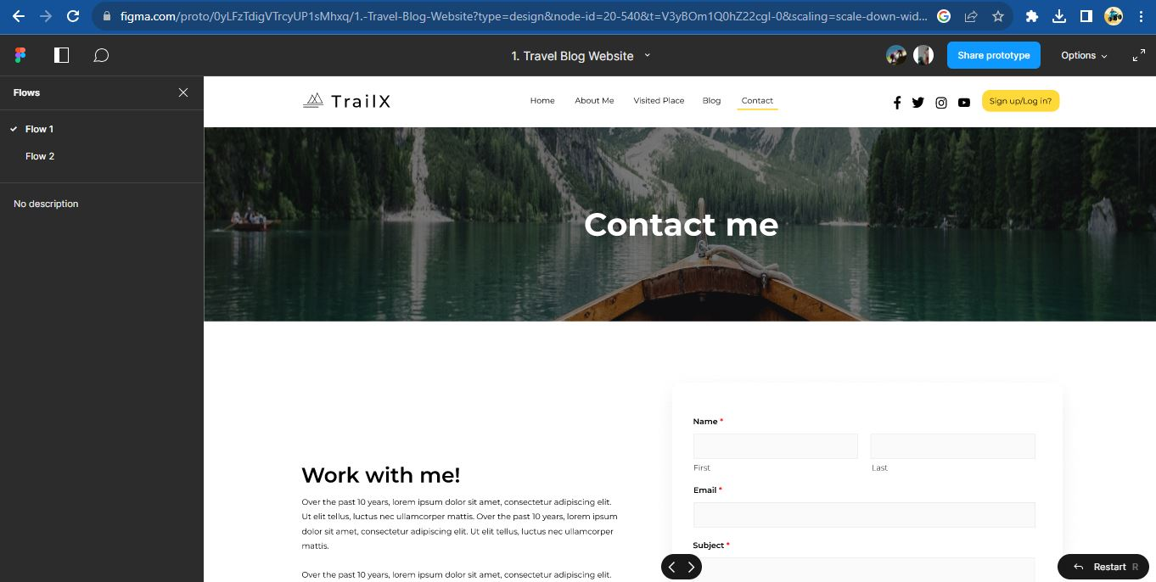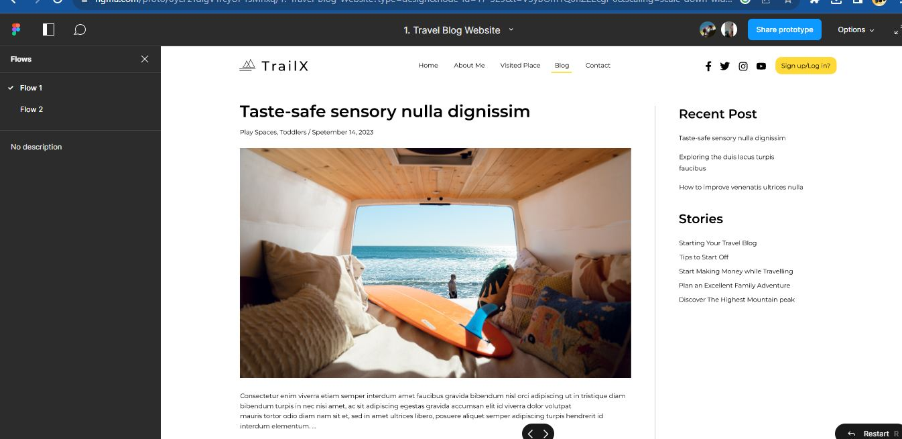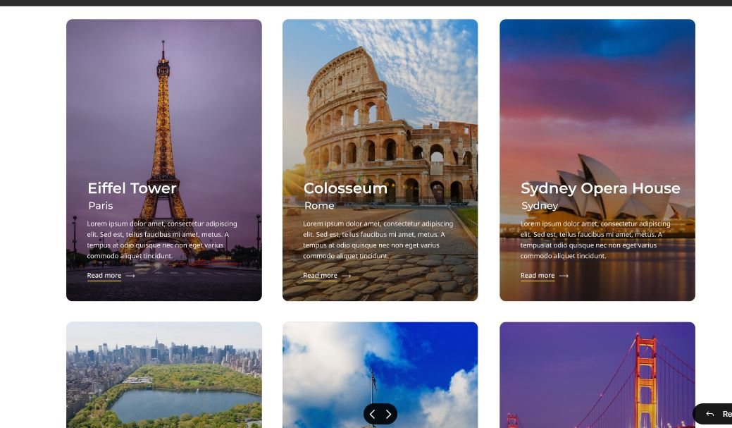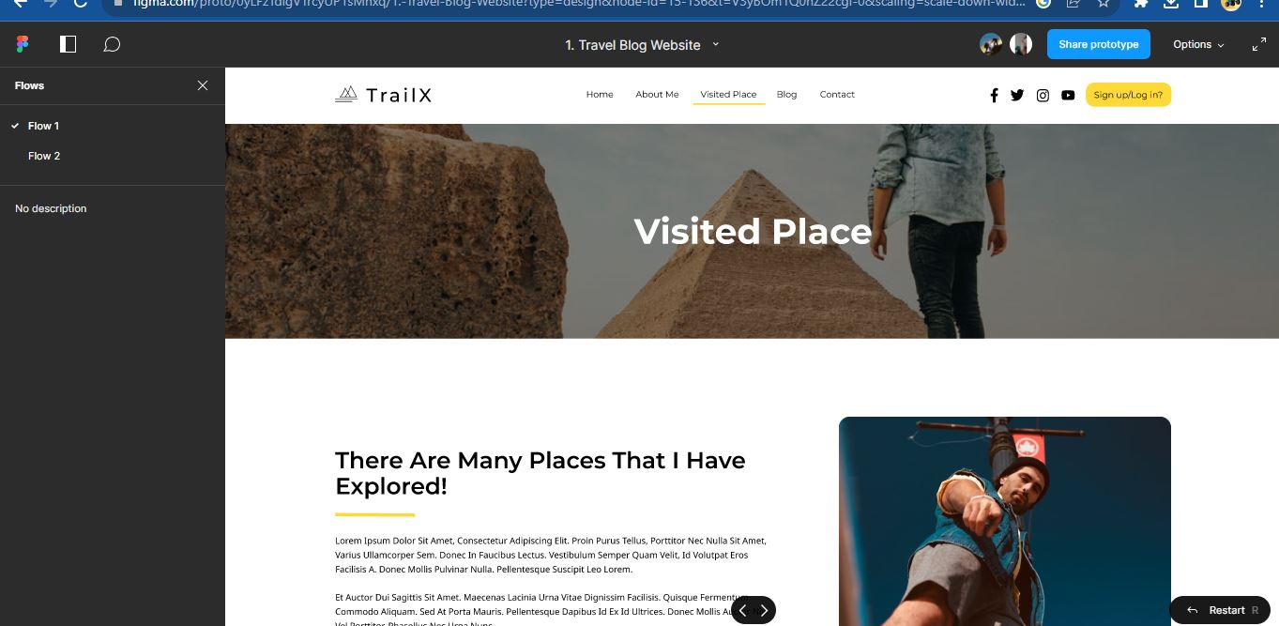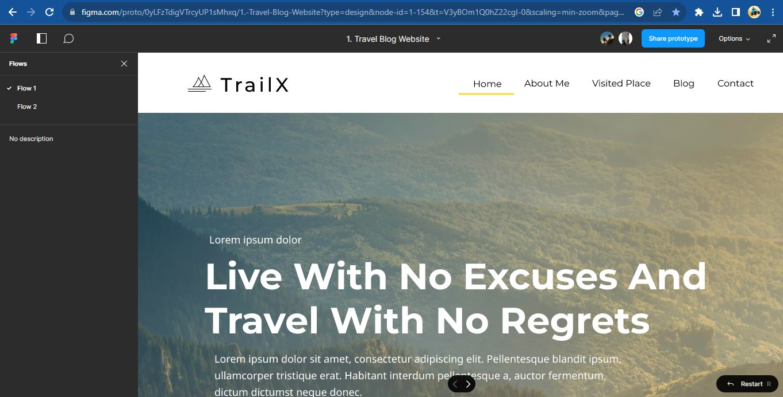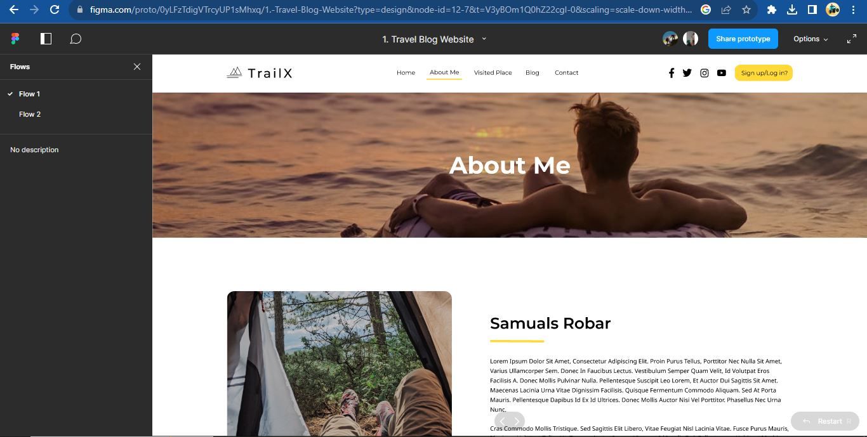

[CHAPTE](https://1.bp.blogspot.com/-dODuK8N5h1Q/Wlnyb3V9HFI/AAAAAAAACL4/WxQtCJ1pM5wccDABg4wIrTBUB0vlikXQQCLcBGAs/s1600/poly1.jpg)R 9

CONCLUSION

* 1. **CONCLUSION**

The package was designed in such a way that future modifications can be done easily. The following conclusions can be deduced from the development of the project:

* Automation of the entire system improves the efficiency
* It provides a friendly graphical user interface which proves to be better when compared to the existing system.
* It gives appropriate access to the authorized users depending on their permissions.
* It effectively overcomes the delay in communications.
* Updating of information becomes so easier
* System security, data security and reliability are the striking features.
* The System has adequate scope for modification in future if it is necessary.

# REFERENCE

****Blogs and Websites****:

* + Nielsen Norman Group (NN/g): [https://www.nngroup.com/](https://www.nngroup.com/" \t "https://chat.openai.com/c/_new)
  + Smashing Magazine: [https://www.smashingmagazine.com/](https://www.smashingmagazine.com/" \t "https://chat.openai.com/c/_new)
  + A List Apart: [https://alistapart.com/](https://alistapart.com/" \t "https://chat.openai.com/c/_new)

****Online Courses and Platforms****:

* + Interaction Design Foundation (IDF): [https://www.interaction-design.org/](https://www.interaction-design.org/" \t "https://chat.openai.com/c/_new)
  + Coursera - UI/UX Design Specialization: [https://www.coursera.org/specializations/ui-ux-design](https://www.coursera.org/specializations/ui-ux-design" \t "https://chat.openai.com/c/_new)
  + Udemy - UI/UX Design Courses: [https://www.udemy.com/courses/design/](https://www.udemy.com/courses/design/" \t "https://chat.openai.com/c/_new)

****YouTube Channels****:

* + The Futur: [https://www.youtube.com/user/TheSkoolRocks](https://www.youtube.com/user/TheSkoolRocks" \t "https://chat.openai.com/c/_new)
  + AJ&Smart: [https://www.youtube.com/user/AJSmartDesign](https://www.youtube.com/user/AJSmartDesign" \t "https://chat.openai.com/c/_new)

****Design Communities and Forums****:

* + Designer News: [https://www.designernews.co/](https://www.designernews.co/" \t "https://chat.openai.com/c/_new)
  + UX Stack Exchange: [https://ux.stackexchange.com/](https://ux.stackexchange.com/" \t "https://chat.openai.com/c/_new)

****Conferences and Events****:

* + UX Design Institute: [https://www.uxdesigninstitute.com/](https://www.uxdesigninstitute.com/" \t "https://chat.openai.com/c/_new)
  + Smashing Design Conference: [https://www.smashingconf.com/](https://www.smashingconf.com/" \t "https://chat.openai.com/c/_new)

****Podcasts****:

* + UX Podcast: [https://uxpodcast.com/](https://uxpodcast.com/" \t "https://chat.openai.com/c/_new)
  + Design Details: [https://designdetails.fm/](https://designdetails.fm/" \t "https://chat.openai.com/c/_new)

****Case Studies and Portfolios****:

* + Behance: [https://www.behance.net/](https://www.behance.net/" \t "https://chat.openai.com/c/_new)
  + Dribbble: [https://dribbble.com/](https://dribbble.com/" \t "https://chat.openai.com/c/_new)

****Design Tools****:

* + Figma: [https://www.figma.com/](https://www.figma.com/" \t "https://chat.openai.com/c/_new)
  + Sketch: [https://www.sketch.com/](https://www.sketch.com/" \t "https://chat.openai.com/c/_new)